**KARNATAKUNIVERSITY**

**DHARWAD**

**Janata Shikshana Samiti’s**

**JSS Shri Manjunatheshwara Institute of PG Studies**

**Vidyagiri, Dharwad-580004.**



**A INTERNSHIP REPORT**

**“ULTIMEZ TECHNOLOGY”**

**INTERNSHIP PERIOD: 10 APRIL TO 10 JUNE**

**BACHELOR OF COMPUTER APPLICATION (BCA)**

**OF**

**KARNATAK UNIVERSITY, DHARWAD**

**Submitted By:**

**ROHIT BALLARI**

**BCA VI SEMESTER**

**UUCMS: U02BF21S0204**

**DEPARTMENT OF COMPUTER SCIENCE**

**2023-2024**

**KARNATAKUNIVERSITY**

**DHARWAD**

**Janata Shikshana Samiti’s**

**JSS Shri Manjunatheshwara Institute of UG & PG Studies**

**Vidyagiri, Dharwad-580004.**



CERTIFICATE

**This is to certify that Mr. ROHIT BALLARI has satisfactorily completed the Internship for the partial fulfilment of BCA prescribed by Karnatak University, Dharwad during the academic year 2023-2024.**

**Prof. Narasimha Bhat Sri. Vivek M Laxmeshwar Dr. Ajith Prasad**

Project Guide HOD, Computer Department Principal

Registration No Examiners:

U02BF21S0204 1)

2)

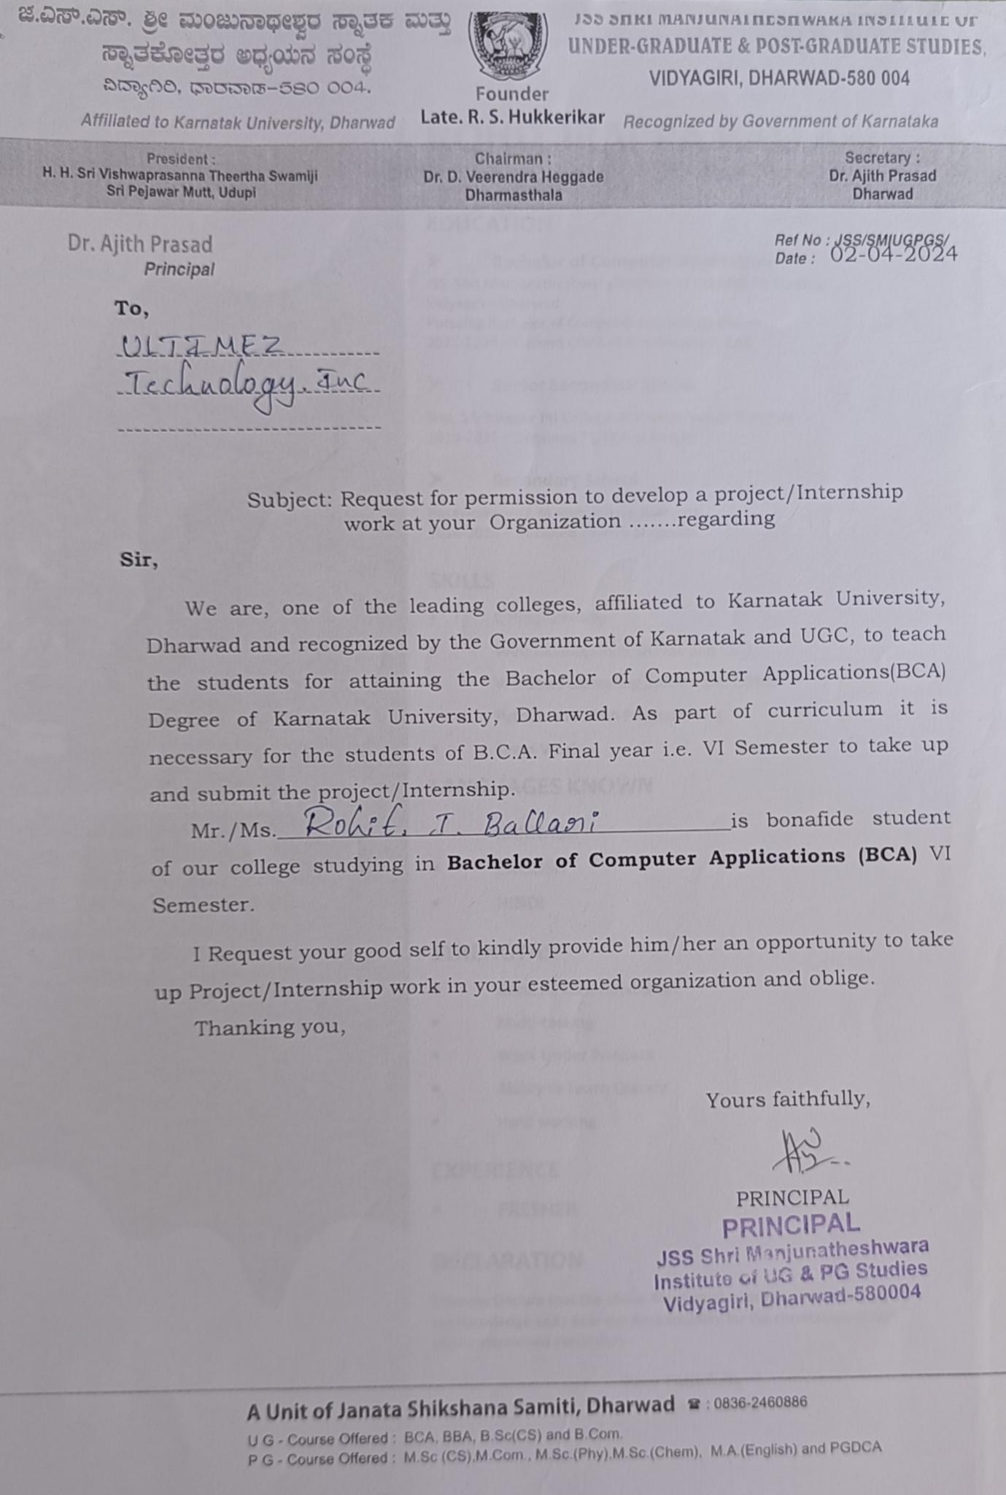

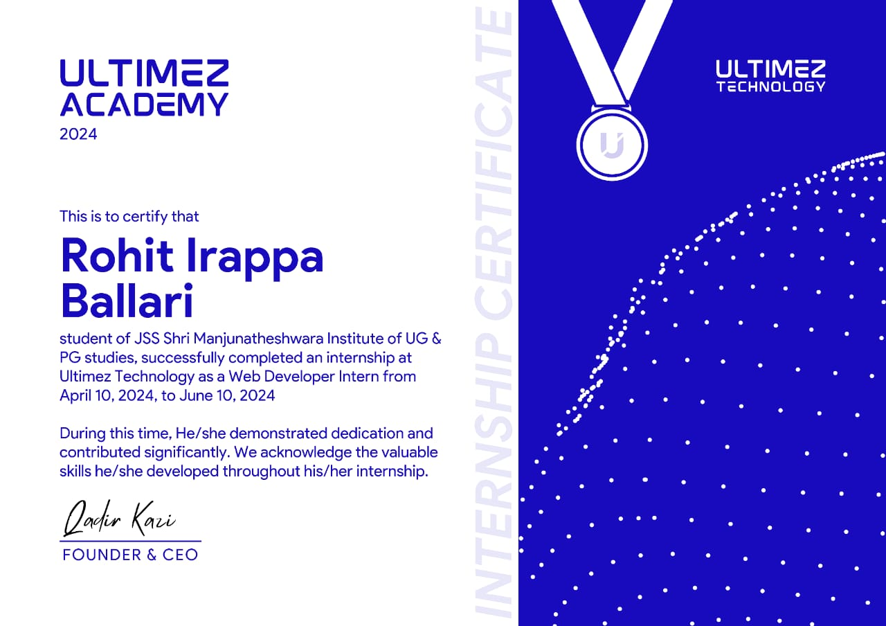

**ACKNOWLEDGEMENT**

**The successful presentation of this Internship is Report of the immense support extended by JSS SMI UG & PG STUDIES, Vidyagiri DHARWAD, which has provided us opportunity to fulfil the most cherished & desired way to reach our goal.**

**I would like to express our heartfelt thanks to our President, Sri Sri Vishwaprasanna Teertha Swamiji of Sri Pejavarmutt, Udupi, Parama Pujya Dr. D. Veerendra Heggadeji, the Chairman of Janata Shikshana Samiti & Dharmadhikari of Shree Kshetra Dharmasthala.**

**I would like to express our Sincere and Hearty thanks of gratitude to our beloved Principal Dr. Ajith Prasad and our Head Of The Computer Science Department Prof. Vivek M. Laxmeshwar who gave us the golden opportunity to do this Internship, which also helped us in doing a lot of research and exposed to lot of new information that would help us in our mere future.**

**I would also take this opportunity to offer our sincere gratitude to our College Internship Guide Prof. Narasimha Bhat for his excellent support throughout the Internship and providing the necessary information on our demand at all the times.**

**I owe a special debt of gratitude to my parents for their constant support, encouragement, and belief in my abilities. Their unwavering support has been a source of strength throughout my academic and professional endeavours.**

**I would like to express our sincere and heartly Thanks of gratitude for M/s. ULTIMEZ TECHNOLOGY, HUBLI for giving an excellent opportunity to work as Intern in their Company, which helped in our present academic year.**

**I would also take this opportunity to offer our sincere gratitude to our Internship Guide, Miss. Nikhataara Jakati, Miss. Aishwarya and our Team Leader Miss. Meenakshi Katigar for their Excellent Support throughout the Internship and providing us the necessary information time-to-time on our demand at all the stages of Internship at ULTIMEZ TECHONOLGY, Hubli**

DECLARATION

**I, ROHIT BALLARI** student of Sixth Semester BCA, Department of Computer Science, JSS Shri Manjunatheshwara Institute OF UG & PG Studies, Vidyagiri, Dharwad affiliated to Karnatak University, Dharwad hereby declare that Internship submitted in partial fulfilment of the course requirement for the award of degree in Bachelor of Computer Application, Karnatak University, Dharwad during the academic year 2024.

**Date: ROHIT BALLARI**

**Place: Dharwad**

**CONTENTS**

|  |  |  |
| --- | --- | --- |
| **SNO** | **Title** | **Page No** |
| **1** | **Information about the company** | **14-16** |
| **2** | **Information about the Internship position** | **17-18** |
| **3** | **Description of Internship**  **experiences** | **19-43** |
| **4** | **Conclusion** | **44** |

1. **INFORMATION ABOUT COMPANY**

**UTLIMEZ TECHNOLOGY**

* 1. **INTRODUTION:**

Ultimez Technology is the professional [Web Design Company Bangalore](https://ultimez.com/), considering all aspects of Web Development & Digital Marketing Solutions at most affordable cost. From a start up enterprises to large enterprises, the Online Presence is must for every business in the Present Generation (Scenario). Online Business doesn’t mean just a website, but well designed, functional mobile friendly and a nice looking website is what matters for visitors to choose you than your competitors.

We are Future Tech Partner for more than 8 Industries, worked with 200 plus prospects for beyond 15 products across 10 countries around the globe.

At Ultimez, we are committed to excel the excellence. We define ourselves by creating differences, continued to grow beyond professionalism and turning businesses into the brand. We are named among the best [Website Designers in India](https://ultimez.com/website-design.html) by Clutch review 2017. Ultimez, as the Professional Industrial Solution firm assists you rise like a shining star among your competitors. Our strong belief in trends over tradition and technology over obstacles directs us creating a newer approach for your business that let your customer fall in love.

**1.2 WHAT THEY DO?**

We are specialized at transforming the creative business idea into interactive web solutions. We offer full fledged web services from web design, development, interactive ecommerce solutions, graphic design, logo design, digital marketing and online brand reputation that make them stand unique amongst their competitors. Ultimez as the interactive web development company in Bangalore provides the fresh, creative and interactive web resolution for your business.

* 1. **COMPANY STRENGTH:**
     1. **One-Stop Internet Solutions Vendor:**

Ultimez is present to build any kind of web development solution. Web design, complex website development, custom programming, dynamic website never matters our highly professional team builds by using current technology and as per market tendency to enhance our client’s business.

* + 1. **Quality Standards:**

Ultimez Technology believes in quality services: We develop web solution which is based on high quality of performance to enhance business needs. We never ever compromise with excellence especially with our client’s project. You can find perfectly combination of quality communication and quality method approach which results in our every web development aspect.

* + 1. **Complete Transparency:**

According to particular requirements we take approach of clients, we follow the method which has systematic and effective performance. Our experts make use of all the necessary segments to enhance complete transparency with the clients.

* + 1. **Full-Cycle Development Services:**

You can find always support from Ultimez in your business requirements such as specification, featured design, testing, validation, coding part of product performance. We provide full-cycle development services to our valuable customers.

* + 1. **Vast Pool of IT Professionals:**

Ultimez has strong team with proficient knowledge to accomplish business goal, we have highly professional IT expertise to structure web solution with the use of present technology to boost the business within competitors and improve visibility over online. We offer web resources before we deliver to our potential clients it should adopt the process which includes quality testing, evaluating, business analysis, right decision then final approach and handout to clients.

**1.4 SERVICES**

1.4.1 **Web and Mobile App Design:**

* Web Design
* Mobile App Design
* Ecommerce Website Design
* UX Design

1.4.2 **Web and Mobile App Development**

* Website Developments
* Mobile App Development
* CMS Website Development
* Blockchain Development
* Travel Software Development

1.4.3 **Online Marketing**

* Search Engine Optimization
* Pay Per Click Services
* Email Marketing
* Social Media Optimization

1.4.4 **Others**

* Server Management
* Integration
* Web Hosting Services
* Domain Name Registration.

**2.INFORMATION ABOUT THE INTERNSHIP POSITION**

**AT ULTIMEZ TECHNOLOGY**

**Internship Position**: Junior Frontend Developer

**Department:** Car Rental Management System (CRMS).

* 1. **Job Description:**

As a Junior Frontend Developer intern at Ultimez Technology, I will be responsible for assisting in the development and maintenance of the company's Learning Management System. My role will involve working closely with senior developers, designers, and other team members to create user-friendly, responsive, and efficient web applications.

* 1. **Key Responsibilities:**
     1. **Frontend Development:**
* Ensure the technical feasibility of UI/UX designs.
* Build reusable code and libraries for future use.
* Ensure the technical feasibility of UI/UX designs.
  + 1. **Collaboration:**
* Work closely with the design team to translate UI/UX designs into interactive web applications.
* Collaborate with backend developers to integrate frontend components with server-side logic.
  + 1. **Code Quality and Testing:**
* Write clean, maintainable, and efficient code.
* Participate in code reviews and provide constructive feedback.
* Conduct testing and debugging to ensure the application works smoothly across different browsers and devices.
  + 1. **Learning and Growth:**
* Continuously learn and stay up-to-date with the latest frontend technologies and best practices.
* Participate in team meetings and contribute to brainstorming sessions.

* 1. **Required Skills:**

**2.3.1 Technical Skills:**

* Proficiency in HTML, CSS, and JavaScript.
* Familiarity with frontend frameworks/libraries such as React, Angular, or Vue.js.
* Understanding of responsive design principles and techniques.
  + 1. **Tools and Technologies:**
* Experience with version control systems like Git.
* Familiarity with build tools such as Webpack, Babel, or Gulp.
  + 1. **Soft Skills:**
* Strong problem-solving skills and attention to detail.
* Good communication skills and the ability to work well in a team.
* Eagerness to learn and adapt to new technologies and challenges.

**3.DESCRIPTION OF INTERNSHIP EXPERIENCES**

**AT ULTIMEZ TECNOLOGY**

Internship offers hands-on training in HTML, CSS, JavaScript, and Bootstrap. Each intern will undertake a personalized project to apply their skills. The course aims to equip interns with essential web development skills and industry best practices. Through practical exercises and collaborative projects, interns will gain proficiency in building responsive web interfaces. The program emphasizes problem-solving and teamwork, fostering collaboration and communication skills. Interns will also receive guidance on creating an online portfolio to showcase their work. The curriculum may be tailored based on interns' progress and skill levels, with guest lectures to supplement learning.

* 1. **Job Description:**

As a Junior Frontend Developer intern at Ultimez Technology, I will be responsible for assisting in the development and maintenance of the company's Learning Management System. My role will involve working closely with senior developers, designers, and other team members to create user-friendly, responsive, and efficient web applications.

* 1. **Objective.**

The objective of a Frontend Developer Internship is to provide a learning experience for individuals interested in building and maintaining the user-facing parts of websites or applications. Here's a more detailed breakdown of the key objectives:

* + 1. **Skill Development:**

Interns acquire practical skills in frontend technologies like HTML, CSS, JavaScript, and frameworks/libraries such as React, Angular, or Vue.js. They learn how to build responsive, interactive, and accessible user interfaces.

* + 1. **Professional Experience**:

Interns gain exposure to real-world projects and work within a development team. This experience helps them understand industry standards, best practices, and workplace dynamics.

* + 1. **Mentorship and Guidance**:

Interns receive mentorship from experienced developers, which provides opportunities for feedback, learning, and career advice.

* + 1. **Team collaboration:**

Interns learn how to work effectively with other developers, designers, and product managers to deliver high-quality user experiences. This involves understanding project requirements, communication, and problem-solving.

* + 1. **Portfolio Building:**

Interns work on projects that they can add to their professional portfolio, demonstrating their skills to potential employers and future teams.

* + 1. **Exploring Career Opportunities:**

The internship allows interns to explore career paths in frontend development and related fields. They can decide whether they want to specialize in frontend, full-stack, or related areas.

* + 1. **Networking:**

Interns have the opportunity to build relationships within the industry, which can lead to future job opportunities, collaborations, or mentorship.

* 1. **Overview:**

Interning at Ultimez Technology provides a unique opportunity for aspiring professionals to gain hands-on experience in a dynamic and innovative environment. As an intern, you will be immersed in real-world projects, receive mentorship from industry experts, and develop skills that are essential for your future career.

* 1. **Key Components of the Internship Experience:**
     1. **Hands-On Projects:**
* **Real-World Applications:** Interns work on actual projects that contribute to the company’s goals. This could include developing new features for the Learning Management System, debugging existing applications, or participating in the design process.
* **Diverse Tasks:** Exposure to various aspects of frontend development, from coding and testing to collaborating with designers and backend developers.
  + 1. **Mentorship and Guidance:**
    - **Experienced Mentors:** Each intern is paired with a mentor who provides guidance, answers questions, and offers feedback on their work.
    - **Regular Check-Ins:** Scheduled meetings to discuss progress, challenges, and career aspirations, ensuring interns receive the support they need.

**:**

* + 1. **Skill Development:**
    - **Technical Skills:** Opportunity to enhance proficiency in HTML, CSS, JavaScript, and modern frontend frameworks like React, Angular, or Vue.js.
    - **Soft Skills:** Improvement in communication, teamwork, problem-solving, and time management skills through collaborative projects and team meetings.
    1. **Learning Opportunities:**
    - **Workshops and Seminars:** Access to various training sessions and workshops focused on the latest technologies and best practices in the industry.
    - **Continuous Learning:** Encouragement to explore new tools and technologies, fostering a culture of continuous improvement.
    1. **Collaborative Environment:**
    - **Team Integration:** Interns are integrated into project teams, attending regular team meetings, and contributing to discussions and decision-making processes.
    - **Networking:** Building connections with professionals across different departments, which can be valuable for future career opportunities.
    1. **Performance Feedback:**
    - **Constructive Criticism:** Regular feedback on performance, highlighting strengths and areas for improvement.
    - **Performance Reviews:** Formal reviews at the end of the internship to evaluate progress and discuss future opportunities.
    1. **Work-Life Balance:**
    - **Flexible Hours:** Many internships offer flexible working hours to accommodate academic schedules.
    - **Supportive Environment:** A culture that values well-being and work-life balance, ensuring interns can perform at their best.
    1. **Company Culture:**
    - **Innovative Atmosphere:** Being part of a company that values creativity, innovation, and a forward-thinking approach.
    - **Inclusive Environment:** A diverse and inclusive workplace where everyone’s ideas and contributions are valued.
    1. **Potential Outcomes:**
* **Enhanced Resume:** Valuable experience to add to your resume, showcasing real-world projects and skills.
* **Professional Growth:** Significant growth in both technical and soft skills, preparing you for future career opportunities.
  1. **Skills Development:**

**HTML**

* **HTML Introduction and syntax:** HTML (Hypertext Markup Language) is the standard language for creating web pages, defining their structure and content. It employs a system of tags and attributes to organize and format elements within a webpage.
* **HTML Elements:** HTML Elements are building block of web pages, defining structure and content. They encompass tags enclosing content and attributes for customization.
* **HTML Attributes:** HTML attributes provide additional information about HMTL and are used to modify the behaviour or appearance of elements within a web page. They enhance accessibility, interactivity, and styling by defining characteristics such as links, images, form, input and more.
* **HTML Lists:** HTML lists are a structures way to organize and present information, providing a concise hierarchical layout for content display on web pages. They offer flexibility for presenting data in ordered, unordered, or definition formats, enhancing readability and user experience.
* **HTML Form:** A structured interface element allowing user to input and submit data to web application or server, facilitating interactive communication between users and digital systems.
* **HTML Tables:** HTML table are structured elements used to organize data into rows and columns within a web page, facilitating presentation and comparison of information. They provide a clear layout for tabular data, enhancing readability and accessibility for users.

**CSS**

* **CSS Introduction and Examples:** CSS stands for Cascading Style Sheets. It's a style sheet language used to describe the presentation of a document written in HTML. CSS allows you to control the layout, colors, fonts, and other visual aspects of your web pages. Examples of CSS include setting the background color of a webpage, changing the font size, or adjusting the spacing between elements.
* **CSS Syntax and Types:** CSS syntax consists of a selector and one or more declarations. Selectors target specific HTML elements, while declarations define how those elements should be styled. CSS has various types, including inline, internal, and external stylesheets. Inline styles are applied directly to HTML elements, internal styles are defined within the `<style>` tag in the HTML document, and external styles are stored in separate CSS files and linked to the HTML document.
* **CSS Selectors:** CSS selectors are patterns used to select and style HTML elements based on their element type, class, ID, attributes, or relationship with other elements. Common selectors include element selectors (e.g., `p` for paragraphs), class selectors (e.g., `.example`), ID selectors (e.g., `#header`), and descendant selectors (e.g., `div p` to select all paragraphs within a `div` element).
* **CSS Color, Text, and Fonts:** CSS allows you to specify colors using various formats such as named colors, hexadecimal, RGB, or HSL values. You can also control text properties like font size, family, weight, style, alignment, and decoration using CSS. Additionally, CSS provides options for styling fonts, including font weight, style, variant, and size.
* **CSS Background and Border:** CSS allows you to set background properties such as background color, image, position, repeat, and attachment. You can also define border properties like border width, style, color, and radius to create borders around elements.
* **CSS Margin and Padding:** Margin and padding are CSS properties used to create space around elements. Margin adds space outside the border of an element, while padding adds space inside the border. You can specify margin and padding values in various units like pixels, or percentages.
* **CSS Box Model:** The CSS box model describes how elements are rendered on a web page. It consists of content, padding, border, and margin. Understanding the box model is essential for designing layouts and positioning elements on a webpage.
* **CSS Tables and Positioning:** CSS provides options for styling tables, including setting table borders, background colors, and cell spacing. CSS positioning allows you to precisely control the placement of elements on a webpage using properties like `position`, `top`, `right`, `bottom`, and `left`.
* **CSS Navigation, Overflow, Inline-block:** CSS navigation refers to styling navigation menus and links on a webpage to improve user navigation. Overflow property controls how content overflows its container, with options like `visible`, `hidden`, `scroll`, or `auto`. Inline-block is a display property that allows elements to flow inline like text while still having block-level properties like margins and padding.

**JavaScript**

* **JavaScript Introduction:** JavaScript is a versatile scripting language used primarily for enhancing interactivity on web pages. It enables dynamic content manipulation and interaction within browsers.
* **JavaScript Variables and Scope:** JavaScript variables store data values. Scope refers to the accessibility of variables, determining where in code they can be referenced.
* **JavaScript Operators and Datatypes:** JavaScript operators are symbols used to perform operations on operands, such as arithmetic, comparison, and logical operations. Datatypes define the type of data stored in variables, including primitives like numbers, strings, Booleans, and complex types like objects and arrays. Understanding these concepts is essential for effective manipulation and evaluation of data in JavaScript programming.
* Top of Form

Bottom of Form

## JavaScript String and its methods: JavaScript strings are sequences of characters enclosed within single or double quotes. They have various methods like toUpperCase(), toLowerCase(), and charAt() for manipulation and retrieval of characters. These methods enable operations like case conversion, character extraction, and substring manipulation.

* **JavaScript Variables and Scope:** JavaScript variables store data values. Scope refers to the accessibility of variables, determining where in code they can be referenced.
* **JavaScript Operators and Datatypes:** JavaScript operators are symbols used to perform operations on operands, such as arithmetic, comparison, and logical operations. Datatypes define the type of data stored in variables, including primitives like numbers, strings, Booleans, and complex types like objects and arrays. Understanding these concepts is essential for effective manipulation and evaluation of data in JavaScript programming.
* Top of Form

Bottom of Form

**Bootstrap**

* **Grid System:** The grid system in Bootstrap is based on rows and columns, allowing you to create responsive layouts. Rows contain columns, and you can adjust the column sizes to create different layouts that adapt to various screen sizes.
* **Container(fluid):** Containers in Bootstrap help to structure the content on your website. A fluid container expands to fill the width of the screen, while a fixed container has a set width.
* **Typography:** Bootstrap offers a set of typography styles and utilities for text formatting and styling.
* **Buttons:** Bootstrap provides pre-styled buttons that you can easily customize. Buttons are essential for user interactions like submitting forms, triggering actions, or navigating through a website.
* Top of Form

Bottom of Form

* **Navbar:** The navbar component in Bootstrap is used for creating navigation bars. It helps users move around the website by providing links to different sections or pages.
* **Popups and Modals:** Popups and models are used to display additional content or messages on top of the main content. Modals, in particular, are great for showing important information or interactive elements without navigating away from the current pages.
* **Pagination:** Pagination is used to divide content into multiple pages, making it easier for users to navigate through a long list of items or articles. It helps improve user experience by breaking up content into manageable sections.

**Vercel**

1. **Deployment and Hosting** 
   * Vercel offers a highly optimized, globally distributed network for deploying static sites and serverless functions.
   * Automated deployment from GitHub, GitLab, and Bitbucket repositories, allowing for continuous deployment workflows.
   * Instant rollbacks and preview URLs for each deployment, facilitating seamless development and collaboration.
2. **Performance and Scalability**
   * Vercel's infrastructure ensures that applications are fast, reliable, and can handle high traffic loads effortlessly.
   * The platform uses edge caching to deliver content quickly by serving it from the closest geographical location to the user.

After completing my training session, I gained hands-on experience as a frontend developer intern at a company. During my internship, I contributed to an exciting project named Car Rental Management System, a comprehensive Car Rental Management System (CRMS). Adiyogi CRMS is an innovative online platform designed to Rent. The Car for the customers. The website offers a wide array of Rent Management, This project allowed me to apply and expand my skills in frontend development while contributing to a valuable Business.

**Project Name:Car Rental Management System**

**INTRODUCTION**

The project is a Car Rental Management System website which, If any user/Customer wants to Take Rent The Car then he can book the Car as per his Requirement.we have designed this website very well which is very good in appearance and working.

* 1. **Problem Statement**

In real world, not every person can afford their own personal car . A car rental is a vehicle that can be used temporarily for a fee during a specified period. Getting a rental car helps people get around despite the fact they do not have access to their own personal vehicle or don't own a vehicle at all. The individual who needs a car must contact a rental car company and contract out for a vehicle. This system increases customer retention and simplify vehicle and staff management.

* 1. **Objective**

• To produce a web-based system that allow customer to register and reserve car online and for the company to effectively manage their car rental business.

• To ease customer’s task whenever they need to rent a car.

• As all the system is computerized, there is no need to fill any application form for renting purpose. So, the paperwork will be very less.

• To make sure a user gets his desire car as early as possible. The car rental system will provide a faster response to complete the process.

* 1. **SQL**

SQL, or Structured Query Language, is a standardized programming language used for managing and manipulating relational databases. It allows users to create, read, update, and delete data within a database. SQL is used to perform tasks such as querying data, creating and modifying database structures, and controlling access to the database.

* 1. **PHP**

PHP, or Hypertext Preprocessor, is a widely-used open-source server-side scripting language specifically designed for web development. It can be embedded within HTML and is commonly used to create dynamic and interactive web pages.

* 1. **HTML5**

HTML, or HyperText Markup Language, is the standard markup language used to create and design documents on the World Wide Web. It structures web content and provides the basic framework for building web pages. HTML elements are represented by tags, which delineate the beginning and end of various parts of the content, such as headings, paragraphs, links, images, and other multimedia.

**1.6 CSS3**

# CSS3, or Cascading Style Sheets Level 3, is the latest evolution of the CSS specification, a style sheet language used to describe the presentation of a document written in HTML or XML. CSS3 is responsible for the look and feel of a website, including layout, colors, fonts, and other visual aspects.

# **JAVASCRIPT**

JavaScript is a high-level, interpreted programming language that is primarily used to create and control dynamic website content. It allows developers to implement complex features on web pages, such as interactive forms, animations, and real-time updates.

**1.7 WAMPSERVER**

# WampServer is a Windows-based web development environment that allows you to create web applications with Apache2, PHP, and a MySQL database. It also includes PhpMyAdmin for database management. WampServer provides a platform to develop and test dynamic websites locally on your computer before deploying them to a live server.

# **REQUIREMENT ANALYSIS AND SPECIFICATION**

**Functional Requirements Car Rental System**

These are statements of services the system should provide, how the system should react to particular inputs and how the system should behave in particular situations. In some cases, the functional requirements may also explicitly state what the system should not do. The functional requirements for a system describe what the system should do. These requirements depend on the type of software being developed, the expected users of the software and the general approach taken by the organization when writing requirements. When expressed as user requirements, the requirements are usually described abstractly. However, functional system requirements describe the system function in detail, its inputs and outputs, exceptions, and so on. Functional requirements for a software system may be expressed in several ways.

The functional requirements of CAR RENTAL SYSTEM is as follow:

**Register Module:**

• The user needs to provide their first name, last name, email, license number, phone number, password, confirm password, gender for registration.

• These details will be stored in database.

**Login Module:**

• For login user will input their email and password .

• Admin will provide their admin id and password which will compared with a database content.

**Booking Module:**

• User can view the list of cars. The booking details of cars are provided by the admin.

• User can select their preferred car and book for the same.

**Payment Module:**

• User should able to make payment by filling card number, expiry date and CVV are provided by the admin.

• After payment user will get the payment successful popup window.

**Logout Module:**

• The system should allow user to logout .

• The system should also allow admin to logout.

# **Non-Functional Requirements of Car Rental System**

# Non-functional requirements are requirements that are not directly concerned with the specific functions delivered by the system. They may relate to emergent system properties such as reliability, response time and store occupancy. Alternatively, they may define constraints on the system such as the capabilities of I/O devices and the data representations used in system interfaces. The plan for implementing functional requirements is detailed in the system design. The plan for implementing non-functional requirements is detailed in the system architecture. Non-functional requirements are often called qualities of a system. Other terms for non-functional requirements are "constraints", "quality attributes", "quality goals", "quality of service requirements" and "non-behavioral requirements". Qualities, that are non-functional requirements, can be divided into two main categories: Execution qualities, such as security and usability, which are observable at run time.

**Security:**

• The system should provide a high level of security and integrity of the data held by the system , only authorized personnel of the company can gain access to the company’s secured page on the system.

• System provides security for the admin by allowing them to enter into the account with their respective ID and password.

• A user can only enter to their account by using their email and password. Only admin have privileges to update database contents which are used by the user.

**Performance:**

• The system should have high performance rate when executing user’s input and should be able to provide feedback or response within a short time span usually 50 seconds for highly complicated task and 20 to 25 seconds for less complicated task.

• The system provides user friendly interface, any common people with little knowledge can use the system.

• System is robust, reliable and fast, provides more efficiency.

**Reliability:**

• It is the probability and percentage of the system performing without any failure for a specific number of uses or amount of time.

• Car rental system provides reliable interface as it provides data security and data safety.

• User can rely on the details present in the system, since it is provided by the admin.

**Consistency:**

• The car rental system provides consistency services, by retaining the data present in the database.

• The user gets the details that are only provided by the admin, thus achieving correctness of data in the database.

**IMPLEMENTATION**

**PHP:** Hypertext Pre-processor (or simply PHP) is a server-side scripting language designed for web development, and also used as a general-purpose programming language. PHP code may be embedded into HTML code, or it can be used in combination with various web template systems, web content management systems, and web frameworks. PHP code is usually processed by a PHP interpreter implemented as a module in the web server or as a Common Gateway Interface (CGI) executable. The web server combines the results of the interpreted and executed PHP code, which may be any type of data, including images, with the generated web page. PHP code may also be executed with a command-line interface (CLI) and can be used to implement standalone graphical applications.

This project uses HTML as front-end tool. Hypertext Mark-up Language (HTML) is the standard mark-up language for creating web pages and web applications. With Cascading Style Sheets (CSS) and JavaScript, it forms a triad of cornerstone technologies for the world wide web. Web browser receive HTML documents from a web server or from local storage and render the documents into multimedia web pages.HTML describes the structure of a web page semantically and originally included cues for the appearance of the document.HTML elements are the building blocks of HTML pages. With HTML constructs, images and other

objects such as interactive forms may be embedded into the rendered page.HTML provides a means to create structured documents by structural semantics for text such as headings, paragraphs, lists, links, quotes and other items.HTML elements are delineated by tags, written using angle brackets. Browsers do not display the HTML tags, but use them to interrupt the content of the page.

# **TESTING**

Software testing is the process of used to identify the correctness, security, completeness and quality of developed computer software. This includes the process of executing the program or applications with the intent of finding errors. An individual unit, functions or procedures of developed project is verified and validated and these units are fit for use.

**5.1 Testing process**

Best testing process is to test each subsystem separately, as we have done in project. Best done during implementation. Best done after small sub-steps of the implementation rather than large chunks. Once each lowest level unit has been tested, units are combined with related units and retested in combination. This proceeds hierarchically bottom-up until the entire system is tested as a whole. **Typical levels of testing:**

• Module- package, abstract data type, class.

• Sub-system- collection of related modules, cluster of classes, method-message paths.

• Acceptance testing- whole system with real data (involve customer, user) Alpha testing is acceptance testing with a single client (common for bespoke systems).

Beta testing involves distributing system to potential customers to use and provide feedback. In this project, beta testing has been followed. This exposes system to situations and errors that might not be anticipated by us

**5.1.1 Unit testing**

Unit testing is the process of testing individual software components unit or modules. Since it needs the detailed knowledge of the internal program design and code this task is done by the programmer and not by testers.

**5.1.2 Integration Testing**

Integration testing is another aspect of testing that is generally done in order to uncover errors associated with the flow of data across interfaces. The unit-tested modules are grouped together and tested in small segment, which makes it easier to isolate and correct errors. This approach is continued until we have integrated all modules to form the system as a whole.After the completion of each module it has been combined with the remaining module to ensure that the project is working properly as expected.

**5.1.3 System Testing**

System testing tests a completely integrated system to verify that it meets its requirements. After the completion of the entire module they are combined together to test whether the entire project is working properly.

**5.2 Test Cases**

A Test Case is a software testing document, which consists of events, action, input, output, expected result and actual result. Technically a test case includes test description, procedure, expected result and remarks. Test cases should be based primarily on the software requirements and developed to verify correct functionality and to establish conditions that reveal potential errors.

|  |  |  |  |
| --- | --- | --- | --- |
| **Test Case No** | **Test Case** | **Expected results** | **Status** |
| 1 | Logging into website | Email and password provided correct | Successful |
| 2 | Logging into website | Email incorrect | Unsuccessful |
| 3 | Logging into website | Password incorrect | Unsuccessful |
| 4 | Logging into website | Any field left empty | Unsuccessful |

**Table 5.1 Test Case for Login**

Table 5.1 represents the test case for login module. It shows both successful and unsuccessful results for the test cases.

|  |  |  |  |
| --- | --- | --- | --- |
| **Test Case No** | **Test Case** | **Expected results** | **Status** |
| 1 | Registration for new user | All details provided correctly | Successful |
| 2 | Registration for new user | Any one field is incorrect | Unsuccessful |
| 3 | Registration for new user | Any field left empty | Unsuccessful |

**Table 5.2 Test Case for Signup**

Table 5.2 represents the test case for sign up module. It shows both successful and unsuccessful results for the test cases.

|  |  |  |  |
| --- | --- | --- | --- |
| **Test Case No** | **Test Case** | **Expected results** | **Status** |
| 1 | Booking | All details provided correctly | Successful |
| 2 | Booking | Any one field is incorrect | Unsuccessful |
| 3 | Booking | Any field left empty | Unsuccessful |

**Table 5.3 Test Case for Booking**

Table 5.3 represents the test case for Booking module. It shows both successful and unsuccessful results for the test cases.

|  |  |  |  |
| --- | --- | --- | --- |
| **Test Case No** | **Test Case** | **Expected results** | **Status** |
| 1 | Feedback | All details provided correctly | Successful |
| 2 | Feedback | All details provided incorrectly | Unsuccessful |
| 3 | Feedback | Any field left empty | Unsuccessful |

**Table 5.4 Test Case for Feedback**

Table 5.4 represents the test case for Feedback module. It shows both successful and unsuccessful results for the test cases.

**SCREENSHOT**

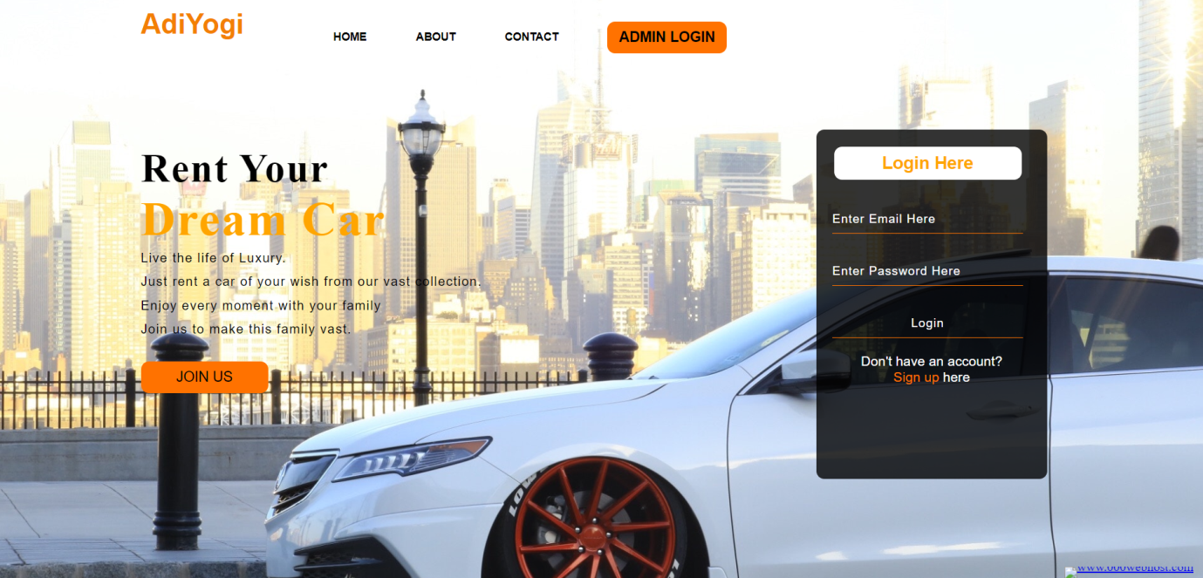

**Figure 6.1 Screenshot of Home page**

Figure 6.1 Indicates the Home page of our Website AdiYogi. This contains navigation bar, through which can navigate to other pages. It also contains some details about the website at the home page.

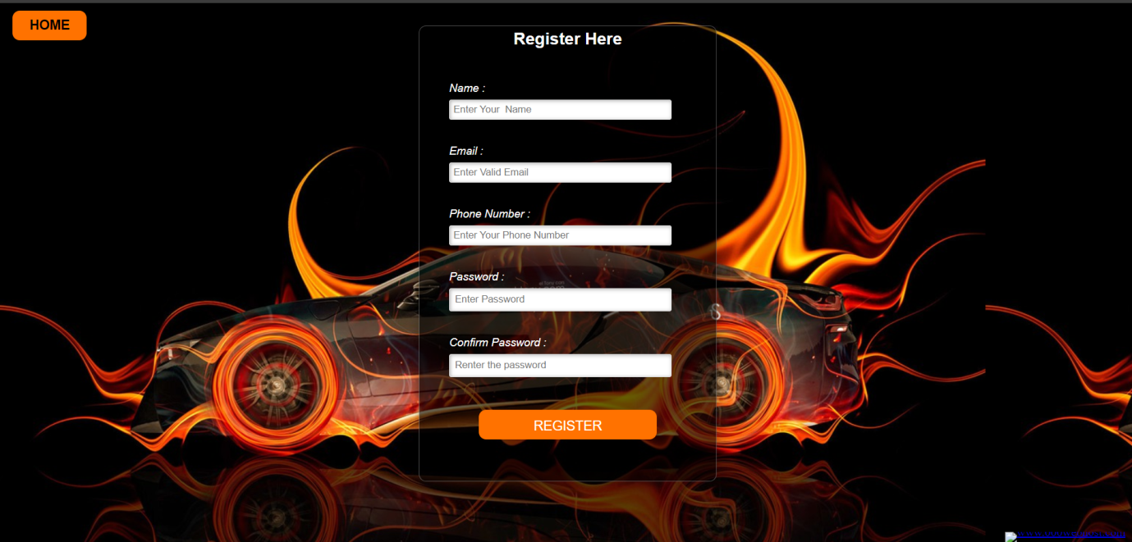

**Figure 6.2 Screenshot of User Registration page**

Figure 6.2 Indicates the user Registration page. It asks the user to enter the details like Name, Email, Phone number, Password, Confirm Password.

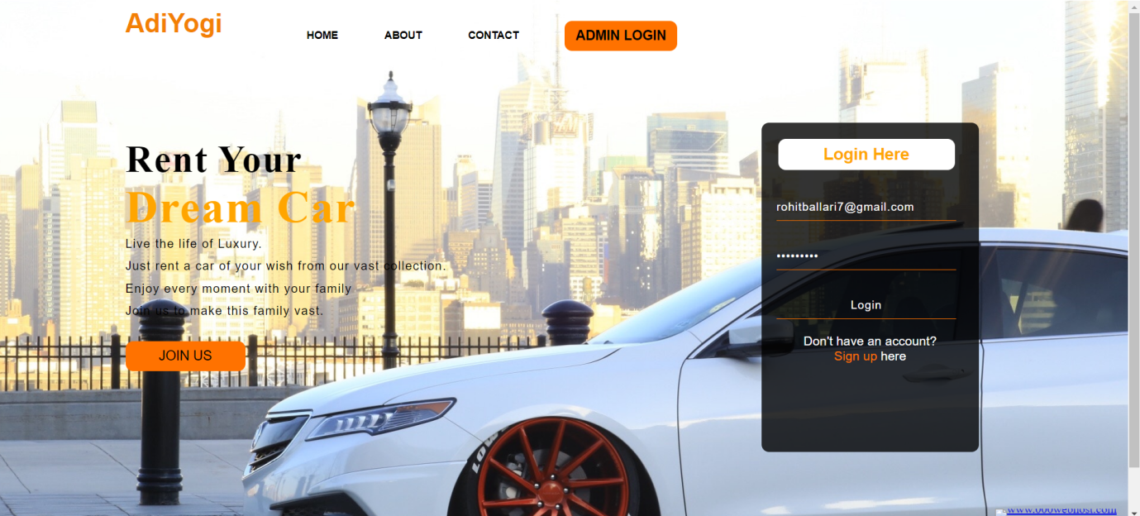

**Figure 6.3 Screenshot of User Login page**

Figure 6.3 Indicates User Login page. It asks the user to enter the email and password in order to enter the website AdiYogi.

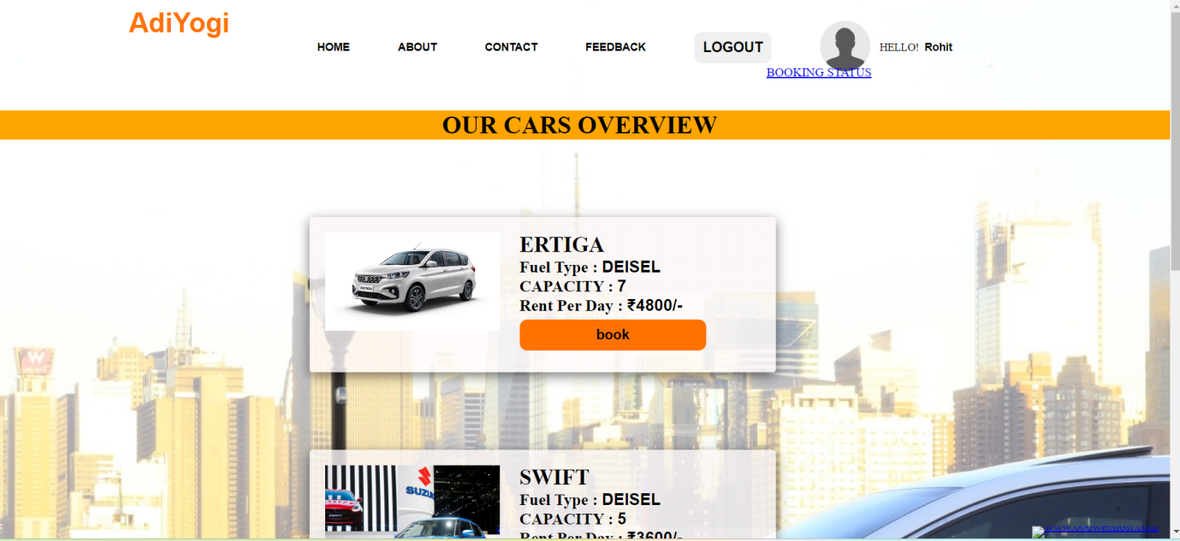

**Figure 6.4 Screenshot of View Car page**

Figure 6.4 Indicates view car page. It asks the user to choose the car it contains the details like fuel type, capacity, rent per day.

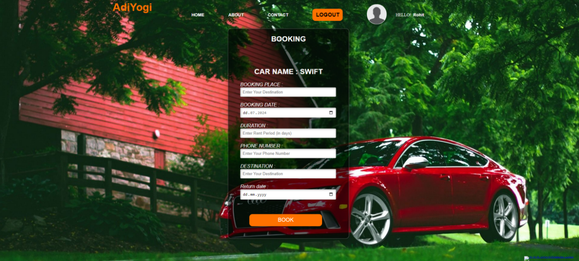

**Figure 6.5 Screenshot of Booking page**

Figure 6.5 Indicates the Booking page.It asks the user to enter booking place,booking date,duration,phone number,destination,return date.

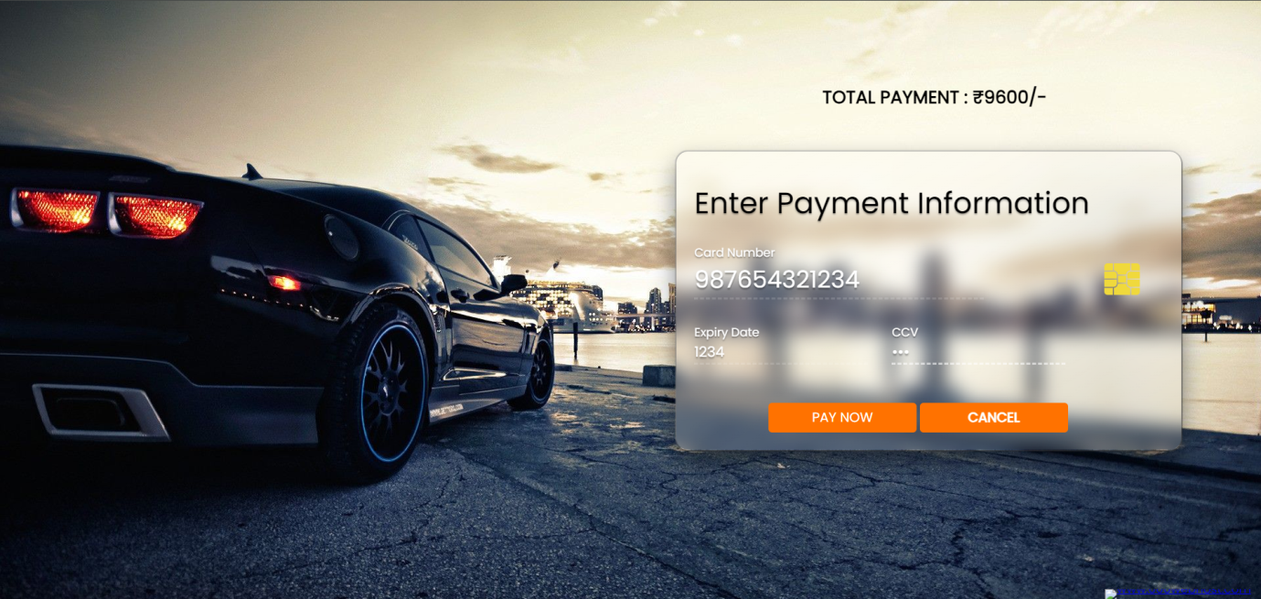

**Figure 6.6 Screenshot of Payment page**

Figure 6.6 Indicates Payment page. It asks the user to enter details like card number, expiry date, cvv.

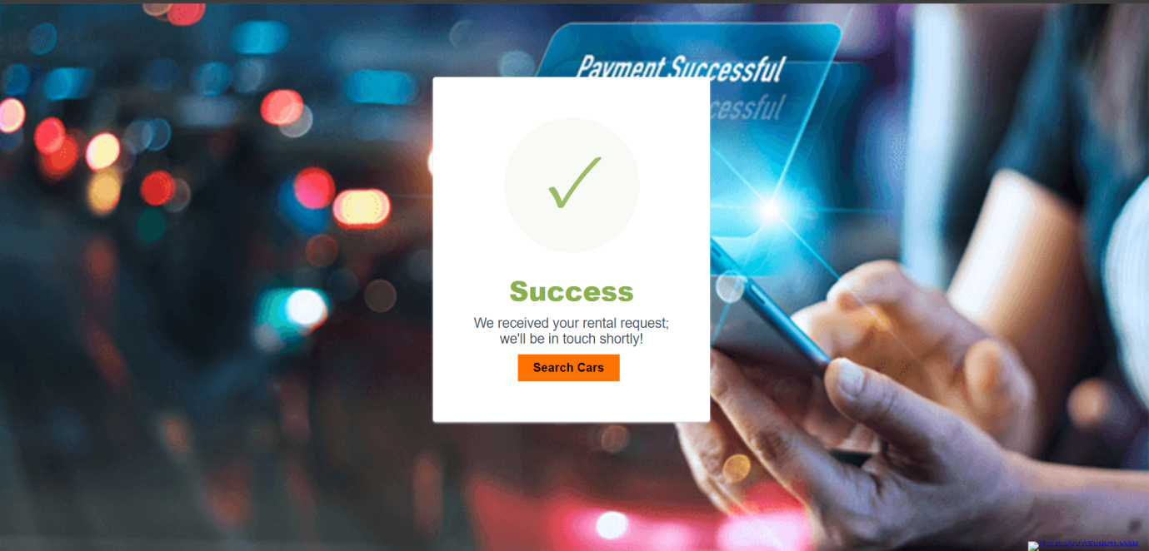

**Figure 6.7 Screenshot of Payment Successful page**

Figure 6.7 Indicates payment successful page.After paying the payment by providing valid information if the payment is successful it shows pop up message that payment is successful.



**Figure 6.8 Screenshot of Booking Status page**

Figure 6.8 Indicates Booking status page.It shows user booking details.

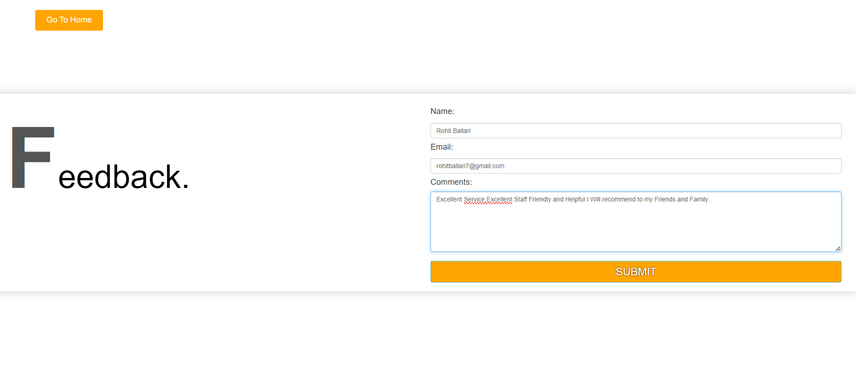**FigFigure 6.9 Screenshot of Feedback Page**

# Figure 6.9 Indicates Feed back page.It asks the user enter details like name,email,comments where registered user can give their valuable feed of their experience .

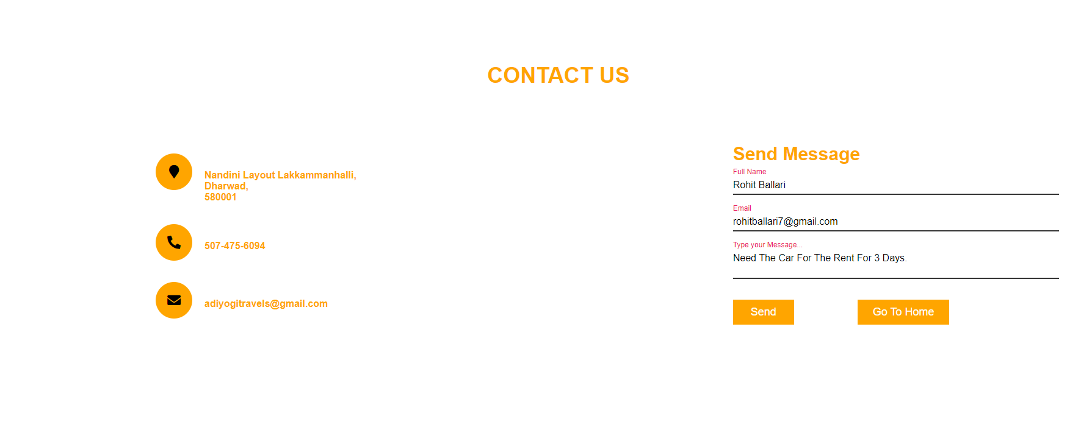**FigFigure 6.10 Screenshot of Contact Us page**

Figure 6.10 Indicates contact us page. It asks the user to enter details like full name, email, message where user can contact the company AdiYogi by sending message.

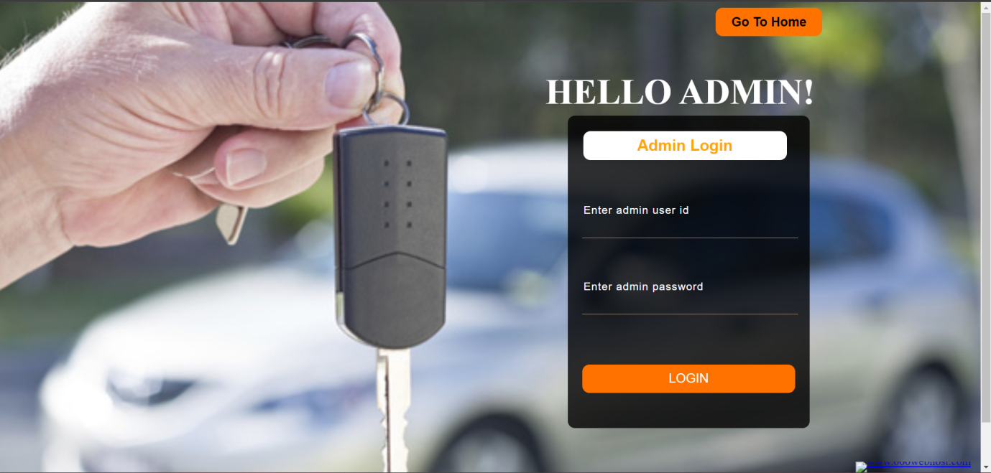

**Figure 6.11 Screenshot of Admin Login page**

Figure 6.11 Indicates admin login page.It asks the admin to enter details like admin_id and password.

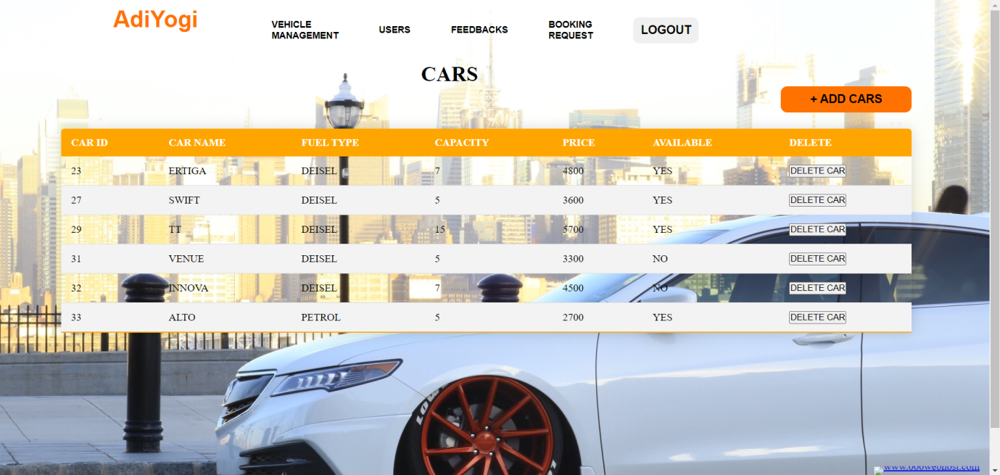

**Figure 6.12 Screenshot of Vehicle Management page**

Figure 6.12 Indicates vehicle management page. It contains the details like car id, car name, fuel type, capacity, price, available, delete where admin can see the car availability status and delete the car details.

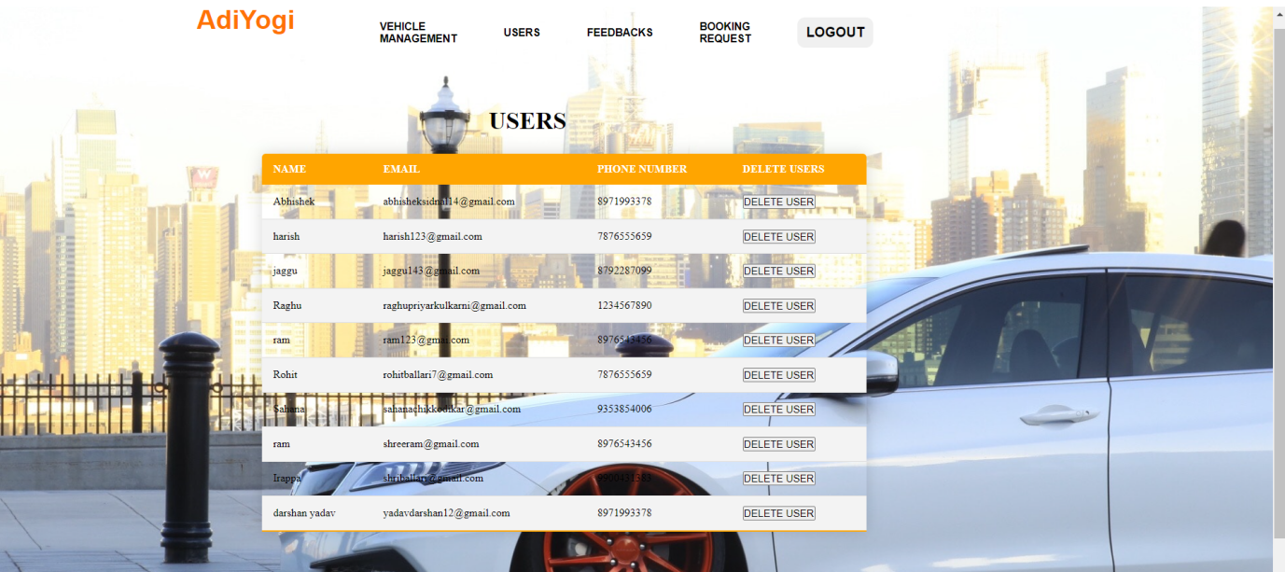

**Figure 6.13 Screenshot of Users page**

Figure 6.13 Indicates User page.It includes details like name,email,license no,phone number,gender,delete user where admin can delete the user details.

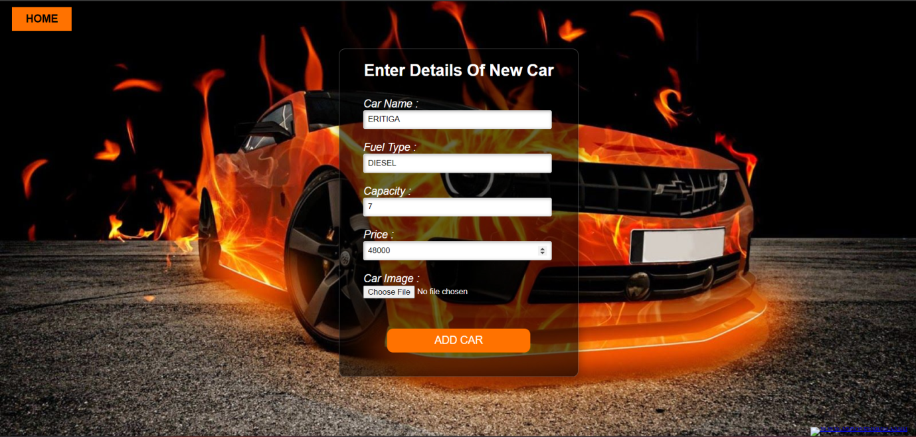

**Figure 6.14 Screenshot of Add Car page**

Figure 6.14 Indicates add car page. It includes details like car name, fuel type, capacity, price, car image where admin can add the new car details by specifying it’s details.

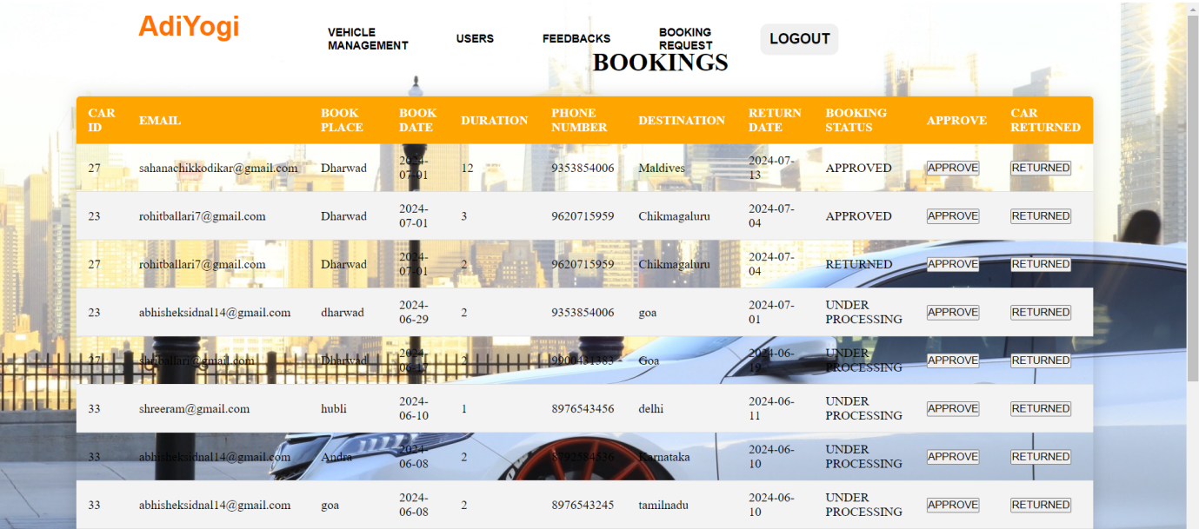

**Figure 6.15 Screenshot of Bookings page**

Figure 6.15 Indicates Booking page. It includes the details like car id, email, book place, book date, phone number, destination, return date, booking status, approve, car returned where admin can give approve to the bookings done by the user and can also check the returned status of the car.

**CONCLUSION**

Online Car Rental Management System is user-friendly and customized software for car renting company. Online Car Rental Management System has been developed to manage and automate the overall processing of any large car renting company. Online Car Rental Management System project is capable of managing cars, booking, feedbacks, payment etc. It is a user friendly and customized software for providing support for company admin. This project is a very flexible software and it can be upgraded according to the individual needs.

During my Internship at Ultimez Technologies, I gained invaluable hands-on experience in the field of your specific area of work, web development. This opportunity allowed me to apply Theoretical knowledge to real-world projects, enhancing my technical skills and understanding of industry practices. Collaborating with a diverse team of professionals helped me develop strong teamwork and communication abilities. The supportive and innovative environment at Ultimez Technologies fostered my growth and adaptability, preparing me for future challenges in my career. Overall, This Internship was a pivotal step in my professional journey, equipping me with the skills and confidence needed to excel in my field.